

**A** **PROJECT REPORT**

**ON**

“ **Stock sell management system POS**”

## Submitted in partial fulfillment for the Course of

**Database Management System Laboratory**

Submitted by:

|  |  |  |
| --- | --- | --- |
| **S/L** | **Name** | **ID** |
| **1** | **Shahin Hasan Antar** | **1846CSE00705** |

Submitted to

|  |
| --- |
| **MEHEDI HASAN**  Department of Computer Science and Engineering Manart International University |

**TABLE OF CONTENTS**

**ABSTRACT**

1. INTRODUCTION
   1. PROJECT AIMS AND OBJECTIVES
   2. BACKGROUND OF PROJECT
   3. SCOPE OF THE PROJECT
2. SYSTEM ANALYSIS
   1. SOFTWARE REQUIREMENT SPECIFICATION
   2. EXISTING VS PROPOSED
   3. SOFTWARE TOOL USED
3. SYSTEM DESIGN
   1. TABLE DESIGN
   2. E-R DIAGRAM OF THE SYSTEM
4. SYSTEM IMPLEMENTATION
   1. MODULE SCREEN SHOTS
5. SYSTEM TESTING
   1. UNIT TESTING
   2. INTEGRATION TESTING
6. CONCLUSION & FUTURE SCOPE

6.1 CONCLUSION

6.2 FUTURE SCOPE

1. REFERENCE

CHAPTER 1

INTRODUCTION

* 1. **PROJECT AIMS AND OBJECTIVES**

To ensure continuous supply of materials spares and finished goods so that production should not suffer at any time and the customer’s demand should also be met. Avoid both overstocking and under-stocking of inventory. For maintain investment in inventories at the optimum level as required by the operational and sales activities. To keep materials cost under control so that they contribute in reducing cost of production and overall cost. Keep inventory at sufficiently high level to perform production and sales activities smoothly. Minimize carrying cost of inventory. Make stability in price.

* 1. **BACKGROUND OF THE PROJECT**

Point of sale inventory management system allows a business owner to have

more than one business location and adequately keep track of inventory at each without being present. No more worries about employee theft or pricing inconsistency between one location and another. The boss can be away and not worry about employee theft. Employee efficiency can be maintained. Point of sale systems take care of those problems that result when management isn't present.

In an early age when the most of the company are still using the manual system in the sales and inventory most of the company encountered so many problems and this is because of the process of the existing system is too slow and too long. According to Kaye Morris (2010), manual inventory management system can help sales and production managers control costs by identifying lost sales due to inventory shortages; inventory overrides on products that are not selling; losses due to employee’s theft or damage. Implementing an inventory management system can take a large amount of time depending on the size and diversity of inventory.

To overcome the deficiencies of manual system, many companies have

automated their inventory system. This system is used to track or monitor the merchandise and goods of a retail store. With an automated Sales and Inventory System, business rely on computers to do tasks that were once performed manually, such as inventory check and product sales. Automated Sales and Inventory System these process can be handled in a timely manner and also be more accurate and reliable than ever before (Hartman, n.d.). It provides greater accuracy and more flexibility in the types of information and reports that can be generated by the system. Point-of-sale systems have replaced traditional cash registers, largely for functionality reasons. POS systems, as they are sometimes called, are relatively easy to use and help provide valuable data for important decision makers. In order to keep up

with the record-keeping needs of small and mid-sized businesses, a good point-of-sale system is a must. Web-based point-of-sale systems are preferred over software based pos systems because they are easily upgradeable, and feature access from multiple computers. The best thing about having a computerized POS System in your retail business is: as new stocks arrives and as it is sold, it keeps the stock levels current and updated,

hence making it is easier to identify which items are selling and which items are not. A POS System is also good in checking for any obsolete or out of date stock that needs to be disposed. If you are still counting your inventory manually on the shelves or in the warehouse, you should think twice about your method, for there are many advantages in using a POS System. One advantage of a POS System is its ability to help your business 3 achieve detailed real-time stock level information. In addition, a POS System can also give you information such as weather forecasts, public holidays and major sporting events, which can be of great help in determining the stock level of seasonal products. You can now efficiently and effectively handle your stock management accurately

* 1. **SCOPE OF THE PROJECT**

Determination of economic order quantity

Formulation of policy

Determination of lead time

Effectiveness towards running of store

Organization structure

They can cover many needs, including valuing the inventory, measuring the change in inventory and planning for future inventory levels. The value of the inventory at the end of each period provides a basis for financial reporting on the balance sheet. Measuring the change in inventory allows the company to determine the cost of inventory sold during the period. This allows the company to plan for future inventory needs.

CHAPTER 2

SYSTEM ANALYSIS

**2.1 SOFTWARE REQUIREMENT SPECIFICATION**

Computer

Windows

XAMPP

MySQL

**2.2 EXISTING VS PROPOSED**

**Existing**

Existing softwares are highly expensive.

Don’t have all in one software.

Different software will needed.

Report needs to be checked Manually.

Search function not so useful.

Much more limitation in them

**Proposed**

Fully Smart.

All sort of branches in the system.

Cheap.

Access to every reports.

All in one place.

**2.3 SOFTWARE TOOL USED**

**TOOLS**

* + - XAMPP/WAMPP Server
    - NetBeans
    - Operating System Windows/MAC
    - Notepad

CHAPTER 3

SYSTEM DESIGN

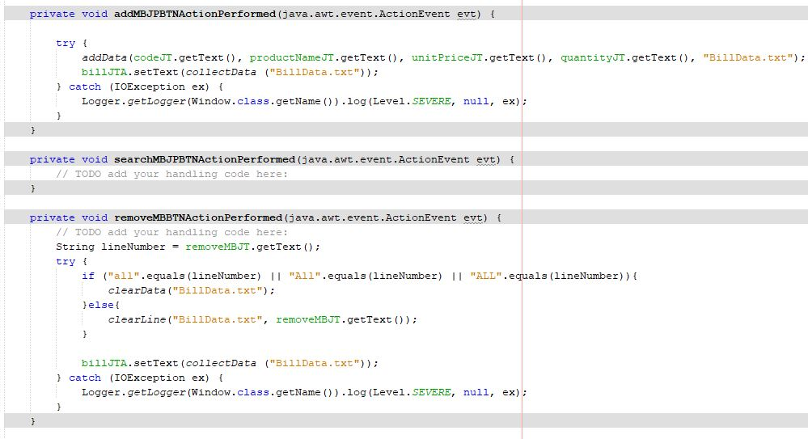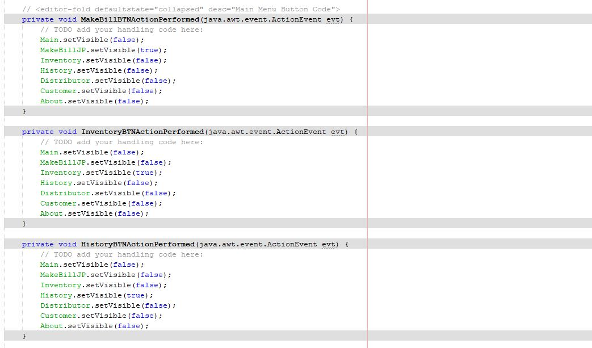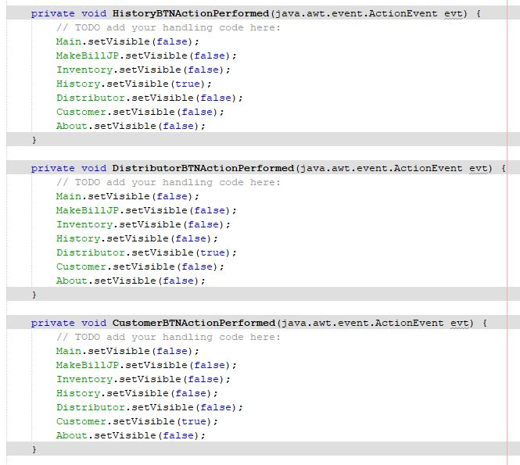

CHAPTER 4

SYSTEM IMPLEMENTATION

* 1. MODULE SCREEN SHOTS

4.1.1 Software interface Design

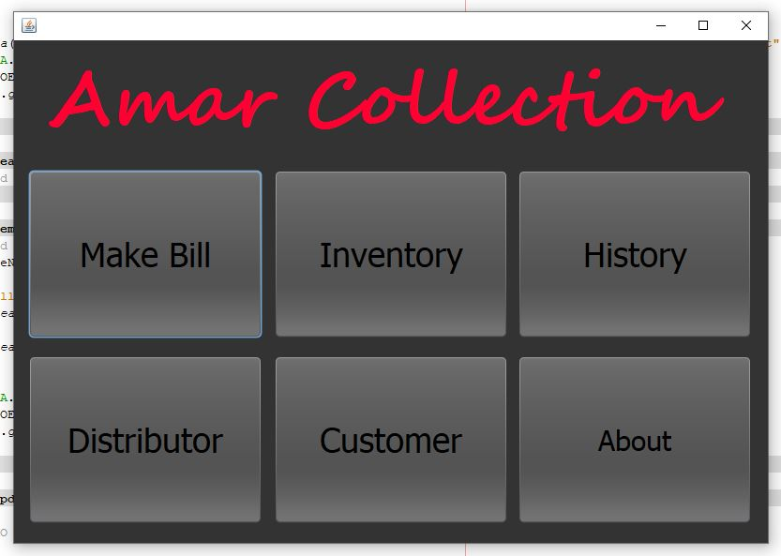

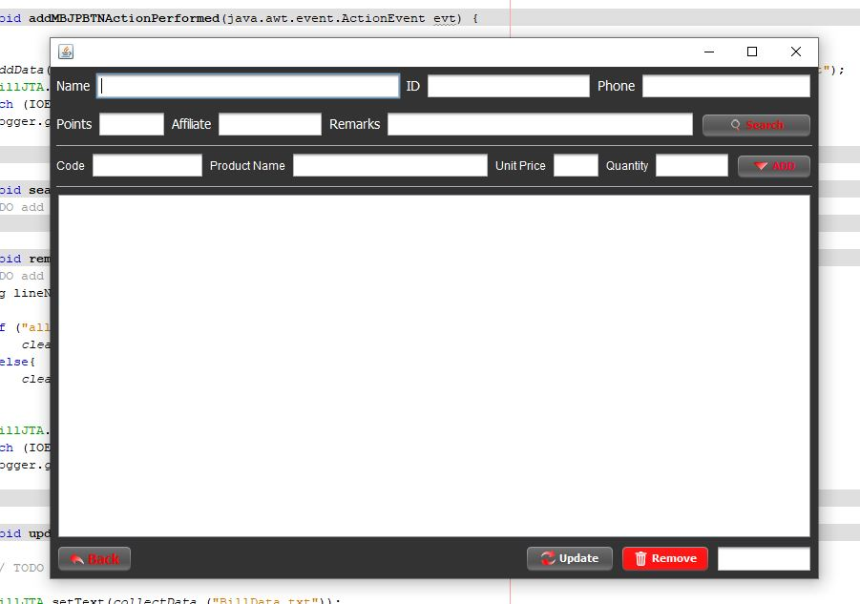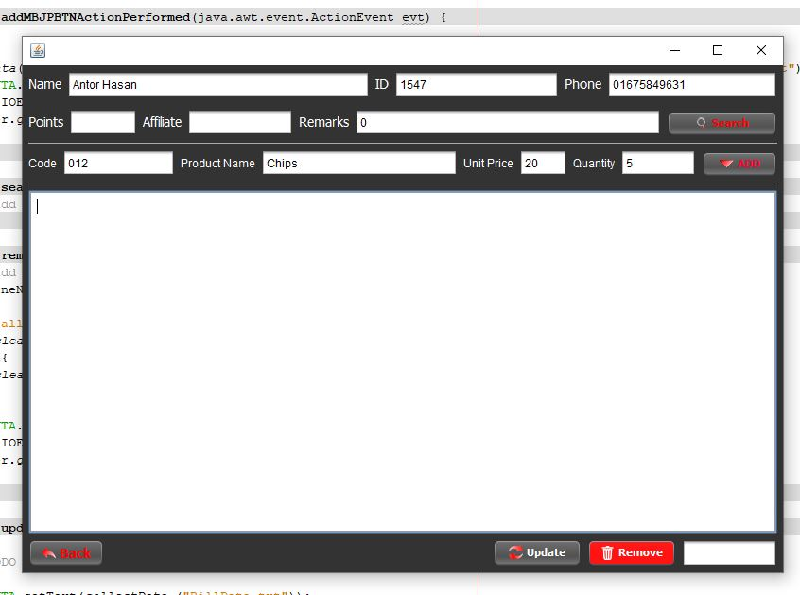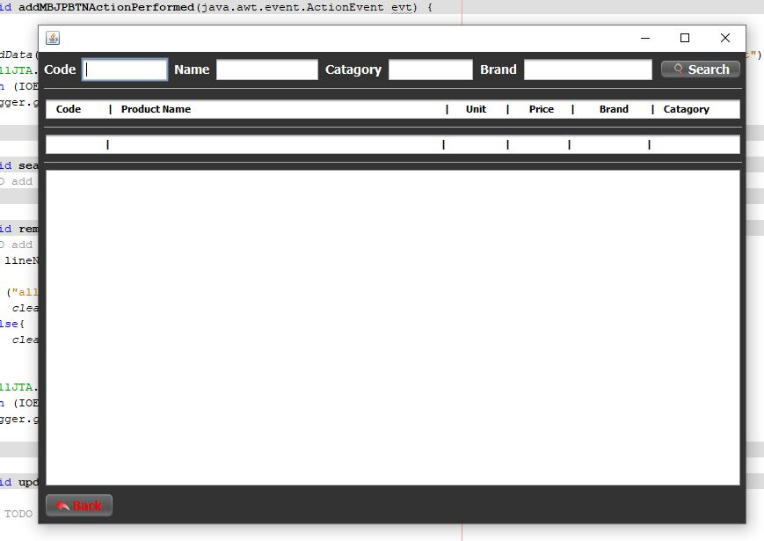

CHAPTER 5

SYSTEM TESTING

**Adding a product**

Product will insert into database:

INSERT INTO `products`(`id`, `Name`, `Issuer`, `Price`, `Purchase_Price`, `Quantity`, `Company`, `Type`, `qty_alert`, `Location`, `Date`, `doe`, `Article_No`, `total_price`, `total_purchese_price`) VALUES (2,’Biscuit’,’raiyan’,’40’,’38’,’2’,’V’,’’,’’,’R’,’2021-10-21’,’’,’0787’,’80’,’76’)

Product table

Database: database_project, Table: products, Purpose: Dumping data

|  |  |  |  |  |  |  |  |  |  |  |  |  |  |  |
| --- | --- | --- | --- | --- | --- | --- | --- | --- | --- | --- | --- | --- | --- | --- |
| id | Name | Issuer | Price | Purchase_Price | Quantity | Company | Type | qty_alert | Location | Date | doe | Article_No | Total_price | total_purchese_  price |
| 1 | Chips | raiyan | 50 | 48 | 10 | c |  | 0 | kafrul | 2021-04-09 | 0000-00-00 | 111 | 500 | 480 |
| 2 | Biscuit | raiyan |  | 40 | 38 | V |  | 0 | R | 2021**-**10**-**21 | 0000-00-00 | 0787 | 80 | 76 |

Adding New Customer

Customer will insert into database:

INSERT INTO `customers`(`id`, `image`, `username`, `first_name`, `last_name`, `mobile`, `email`, `NID`, `address`, `address2`, `About`, `Issuer`, `date`, `due`, `Expected_Payment_Date`, `DateofJoin`, `Card`) VALUES (2,’Tamim’,Tamim,Hasan,’01515205628’,’dwdewd@gmail.com’,’97089’,’north kafrul’,’’,’’,’raiyan’,’2021-04-08’,’’0,’’,0, 2021-04-08’,9088845)

Customer table

Database: database_project, Table: customers, Purpose: Dumping data

|  |  |  |  |  |  |  |  |  |  |  |  |  |  |  |  |
| --- | --- | --- | --- | --- | --- | --- | --- | --- | --- | --- | --- | --- | --- | --- | --- |
| id | username | first_name | last_name | mobile | email | NID | address | address2 | About | Issuer | date | due | Expected_Payment_Date | DateofJoin | Card |
| 1 | Ryan | Ryan | sarar | 01515205628 | raiyankhan0@gmail.com |  | North Kafrul |  |  | raiyan | 2021-04-09 | 0 | 0000-00-00 | 2021-04-09 | 0 |
| 2 | Tamim | Tamim | Hasan | 01515205628 | raiyankhan0@gmail.com | 97089 | North Kafrul |  |  | raiyan |  | 0 |  |  | 9088845 |

**Make BILL**

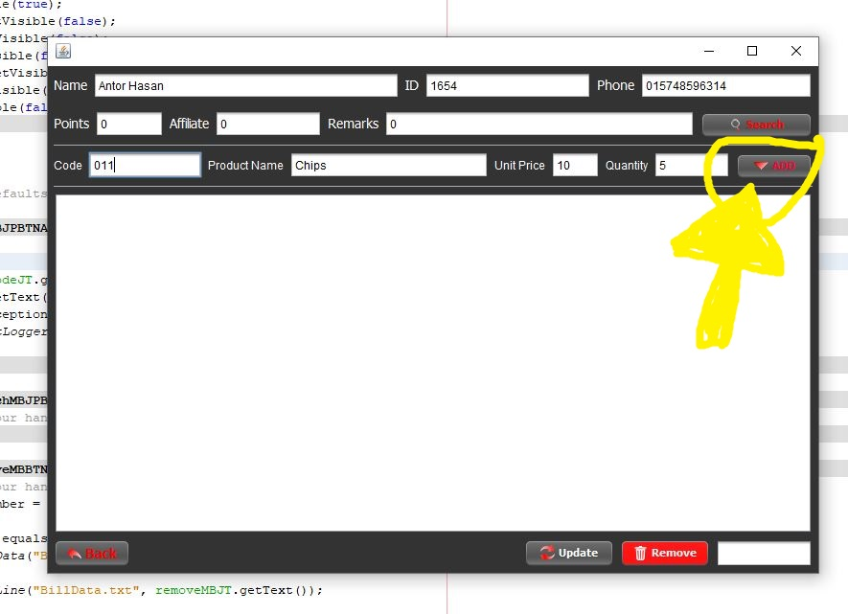

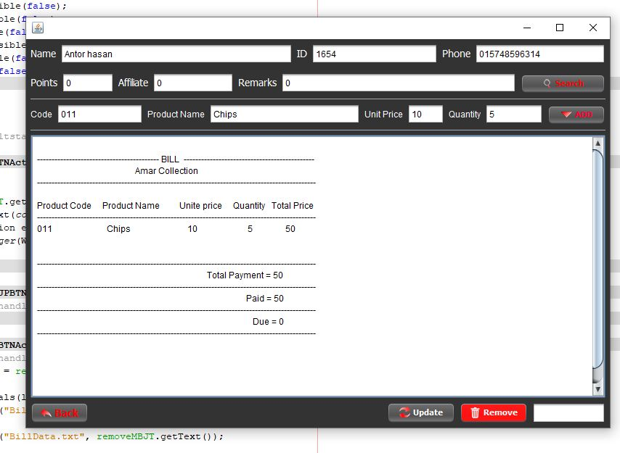

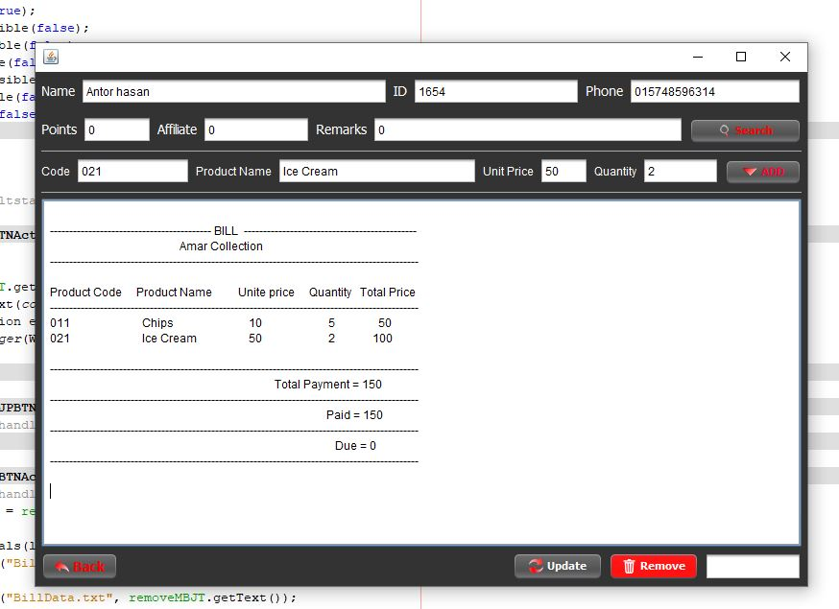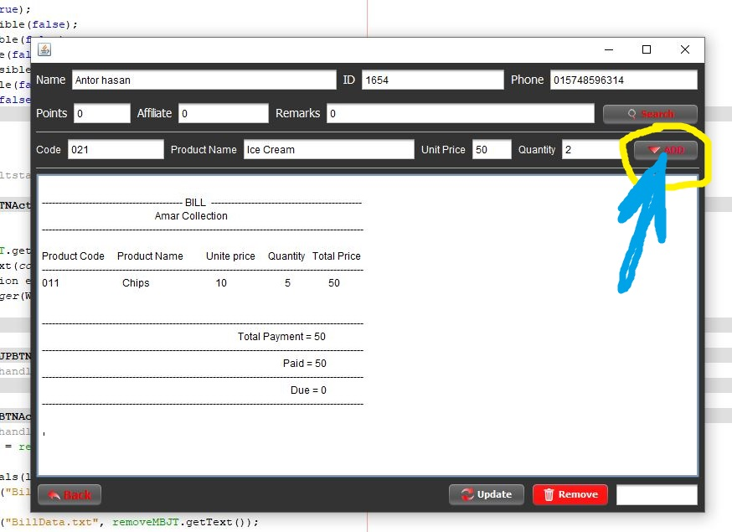

CHAPTER 6

CONCLUSION AND FUTURE SCOPE

**Future Scope**

Determination of economic order quantity

Formulation of policy

Determination of lead time

Effectiveness towards running of store

Organization structure.

They can cover many needs, including valuing the inventory, measuring the change in inventory and planning for future inventory levels. The value of the inventory at the end of each period provides a basis for financial reporting on the balance sheet. Measuring the change in inventory allows the company to determine the cost of inventory sold during the period. This allows the company to plan for future inventory needs.

**Conclusion**

 Inventory management has to do with keeping accurate records of goods that are ready for shipment. This often means having enough stock of goods to the inventory totals as well as subtracting the most recent shipments of finished goods to buyers. When the company has a return policy in place, there is usually a sub-category contained in the finished goods inventory to account for any returned goods that are reclassified or second grade quality. Accurately maintaining figures on the finished goods inventory makes it possible to quickly convey information to sales personnel as to what is available and ready for shipment at any given time by buyer. Inventory management is important for keeping costs down, while meeting regulation. Supply and demand is a delicate balance, and inventory management hopes to ensure that the balance is undisturbed. Highly trained Inventory management and high-quality software will help make Inventory management a success. The ROI of Inventory management will be seen in the forms of increased revenue and profits, positive employee atmosphere, and on overall increase of customer satisfaction.

CHAPTER 7

REFERENCES

**IDE**

<https://netbeans.apache.org/>

**Git Represatory**

<https://github.com/sahinhasanantar/POSit>

**Video Presentation**

<https://drive.google.com/file/d/1Wk6YXTLmi0ynw8PQ-1XxoacCPwR2l1kW/view?usp=sharing>